**INDIVIDUAL DIARY**

**Name: YEOH HUI JIA**

**Date: 2nd March 2015**

I attended the first lecture for CSCI321 where Luke briefed us about the purpose and the requirements for the project. After that we met up in my place to look through videos related to Leap Motion and the Oculus Rift. The links are compiled in Shien Wee’s diary.

Besides that, we also discussed several requirements and issues that we might face when developing for this project and agreed to bring this issue to our supervisor.

**Name: YEOH HUI JIA**

**Date: 3rd March 2015**

We met up with our supervisor, Koren and we discussed about what is required for our project, including possible software development kits for the project. Besides, we pretty much laid out our stretch goal for the first part of the project – which includes coming up with the requirements and learning up the SDKs required for the project. Another meeting will be due with Koren to obtain the Leap Motion device.

In addition, Koren also advised us on how the typing tutor’s structure ought to be, in terms of the stages of the typing tutor that the user will experience to improve/learn typing.

**Name: YEOH HUI JIA**

**Date: 8th March 2015**

Over the period of 4 to 5 days, I’ve done some research on the Unity game engine and its functions by watching tutorials on Youtube done by experienced Unity users. I have also read through some tutorials posted on Unity’s website on how to develop some simple survival first person shooter game- since the project is somewhat also based on a first person shooter angle.

I am still looking up on different tutorials and most of which might suit the requirements of the project such that it will be able to ease the development of the project in the later phases.

Kapil has gotten the Leap Motion from Koren and I have tested it out with my group members- mainly on the Leap’s sensitivity and its range of detecting the presence of the hand. The various mini games and applications that the Leap Motion software provided allowed us to have a better grasp of the Leap’s mechanism besides enabling us to familiarize ourselves with the hardware itself.

The following is one of the tutorial link that I found on Youtube by Brackey, a small game development company:

<https://www.youtube.com/watch?v=fRED_-LvJKQ>

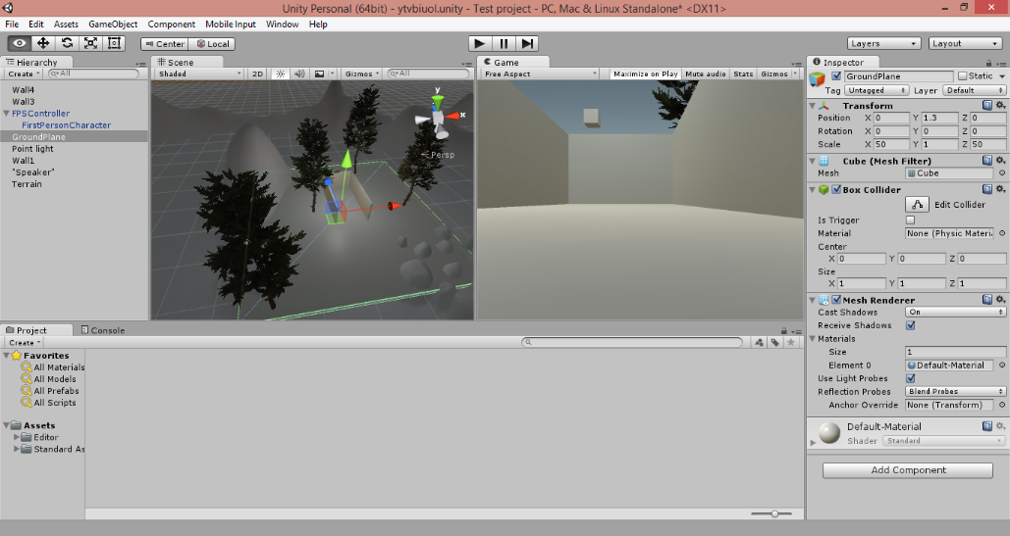and this is part of the result of me testing it out on the Unity SDK (the hills and trees were added randomly):